I have created an AuthenticatorApp using Firebase.

In this application I have implemented firebase email authentication system where user can create new account, login using the email and password.

**Features**

1. Create New account with email
2. Saved user Data with FireStore
3. Forgot Password options
4. Verify User Email

* PLATFORM USED: ANDROID STUDIO 4.0
* The language used: Java, XML
* Database: Firebase

I'm attaching Sreenshots of the App:

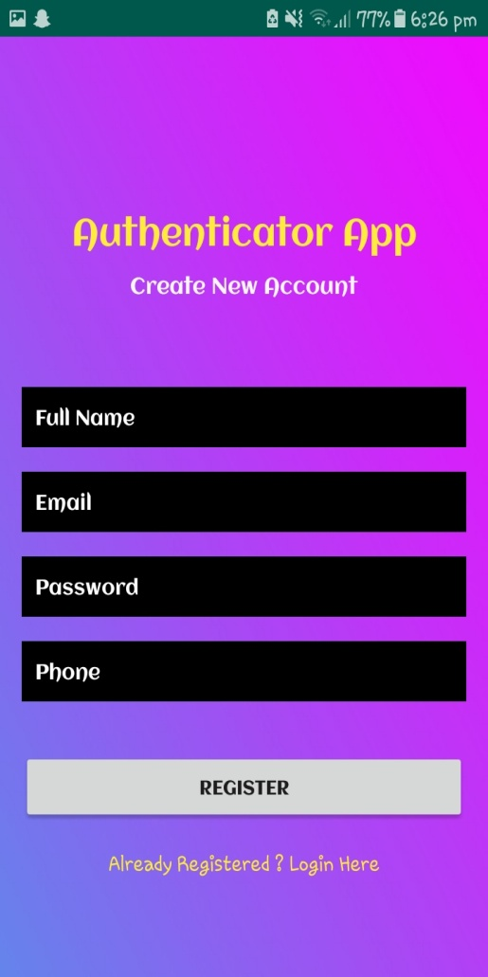 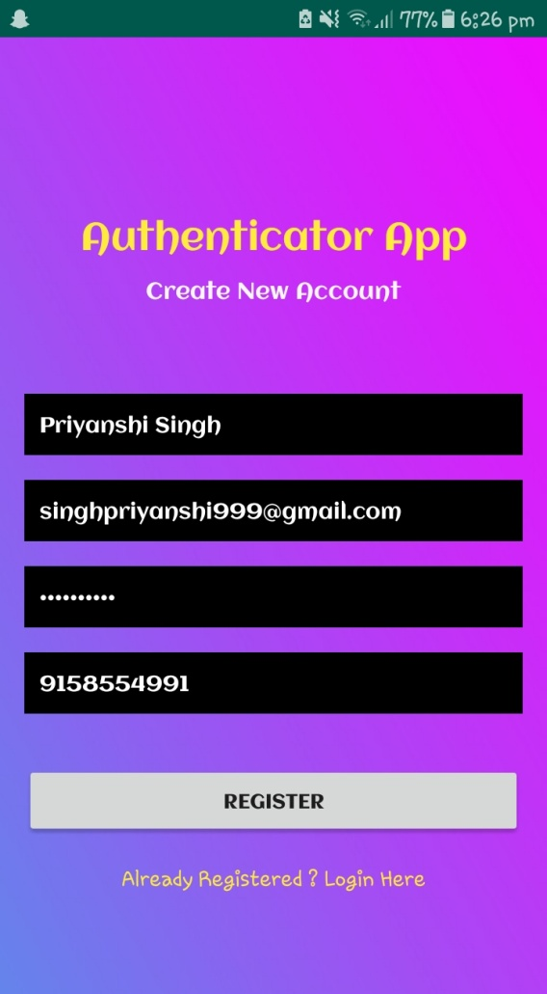

CREATE NEW USER FOR FIRST TIME

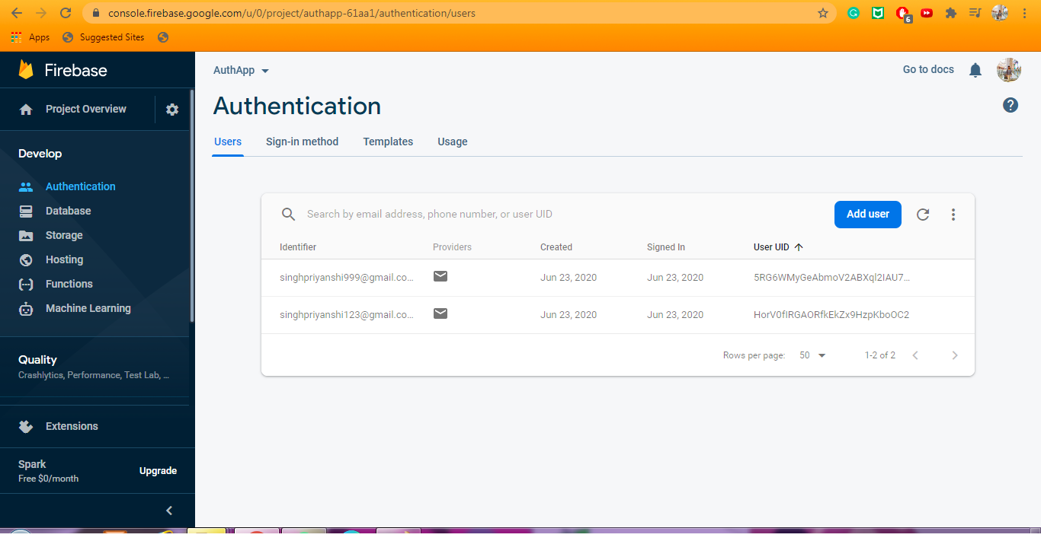

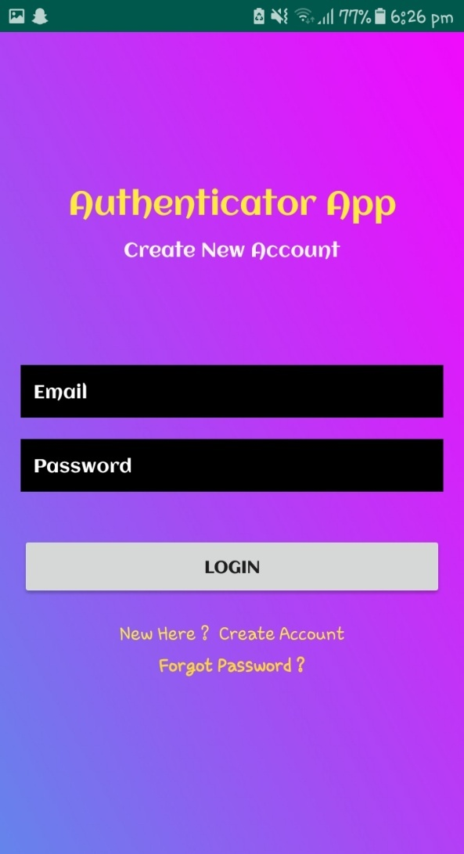 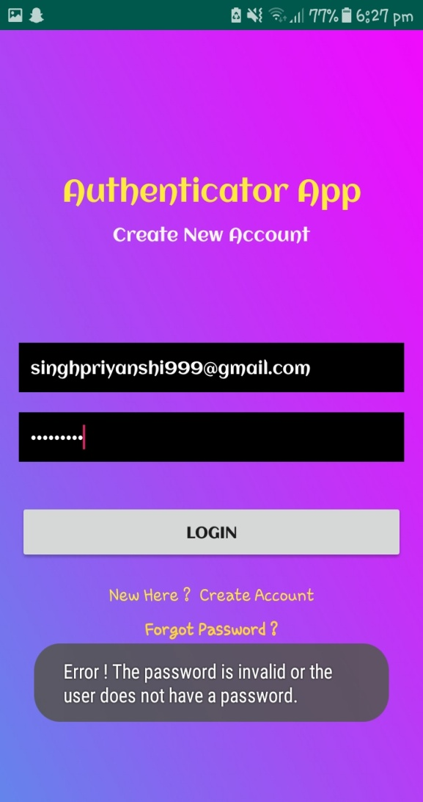

LOGIN ALREADY EXISTING USER…N TOAST IF PASSWORD IS WRONG

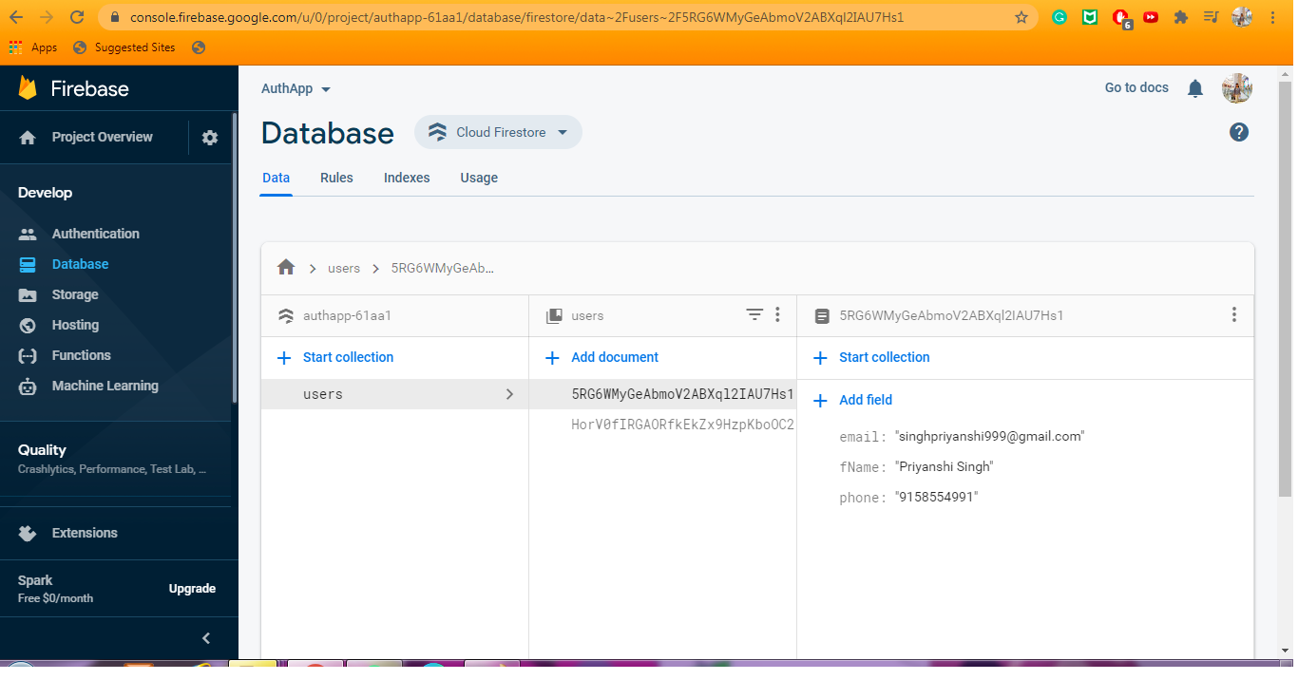

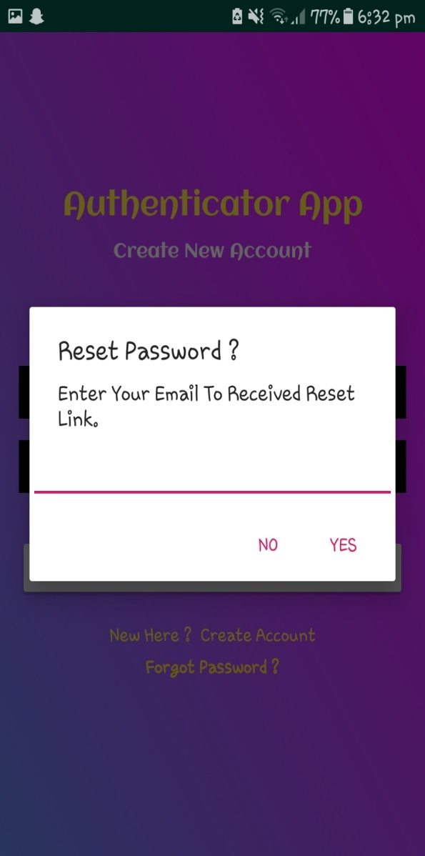 fORGOT PASSWORD

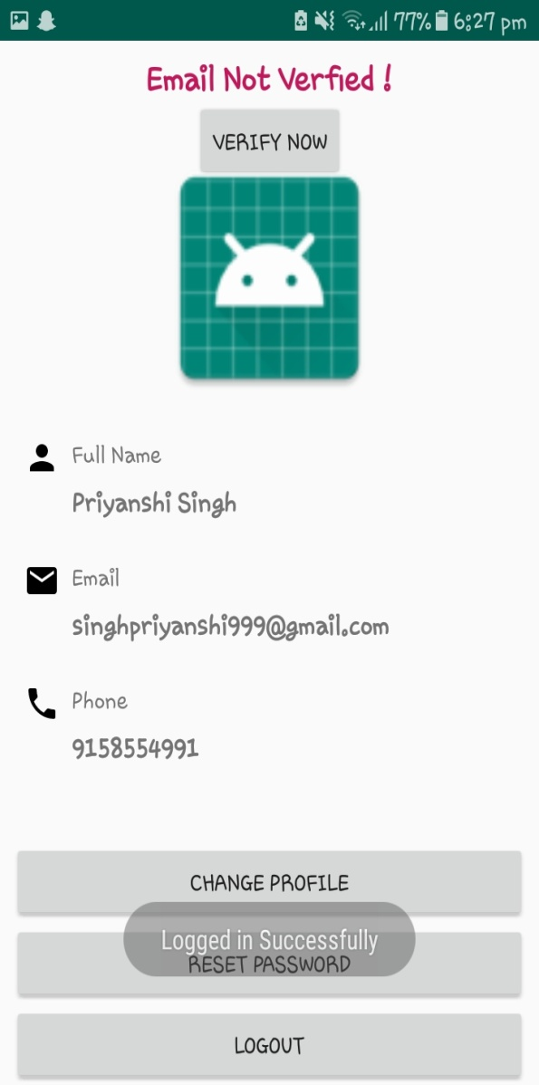

SUCCESSFUL LOGIN SHOWS USER DATA

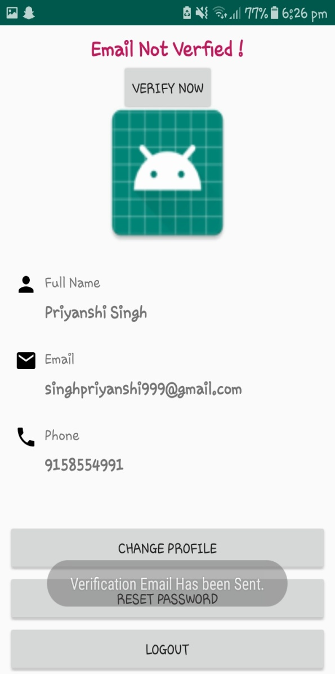

SEND MAIL FOR EMAIL VERIFICATION

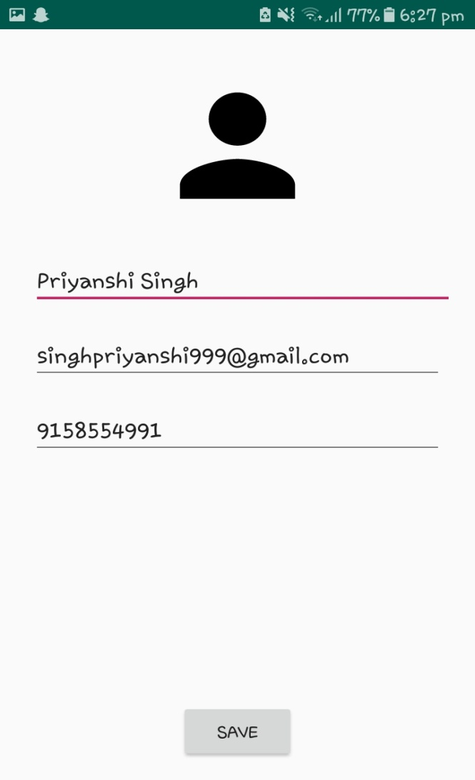 EDIT PROFILE

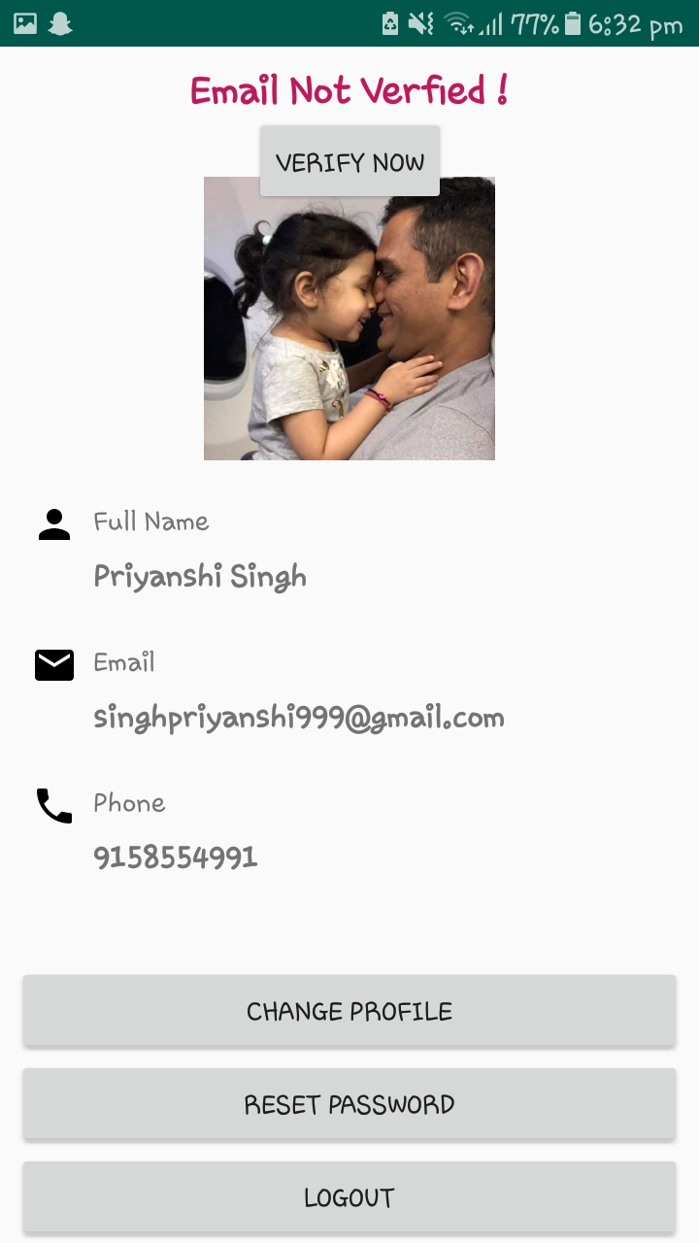 CHANGE PROFILE PICTURE

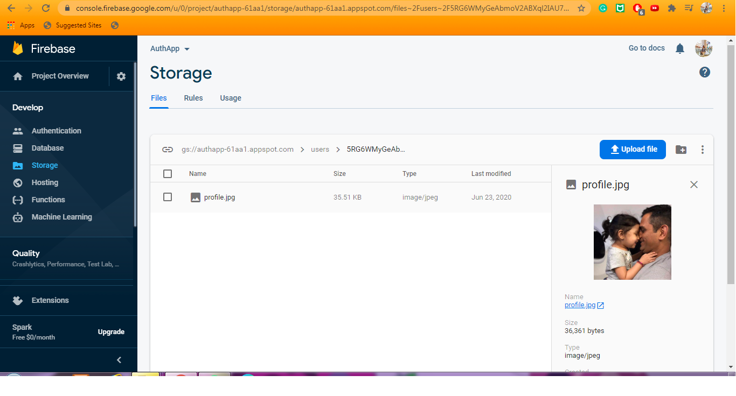

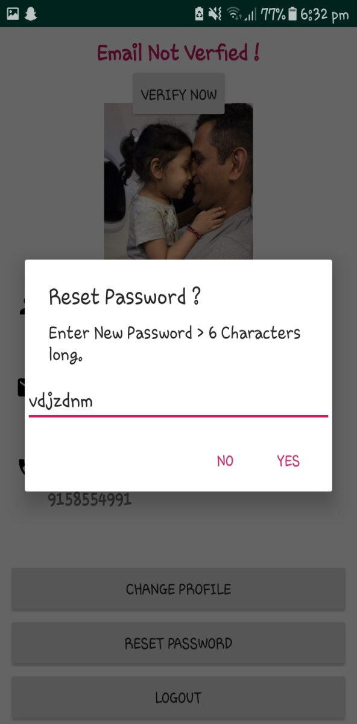 CHANGE PASSWORD FOR ALREADY EXISTING USER